Exercices Vecteurs 2

Exercice 1

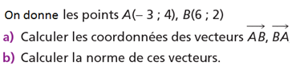
……………………………………………………………………………………
……………………………………………………………………………………
……………………………………………………………………………………
……………………………………………………………………….………..…
…………………………………………………………………………………………………………………………………………………………………………………………….……..……….
…………………………………………………………………………………………………………………………………………………………………………………………….……..……….
…………………………………………………………………………………………………………………………………………………………………………………………….……..……….

Exercice 2
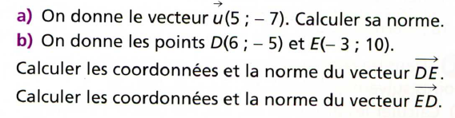
…………………………………………………………………………………………
…………………………………………………………………………………………
…………………………………………………………………………………………
………………………………………………………………………………..………
…………………………………………………………………………………………………………………………………………………………………………………………….…………….
…………………………………………………………………………………………………………………………………………………………………………………………….……..……….
…………………………………………………………………………………………………………………………………………………………………………………………….……..……….
…………………………………………………………………………………………………………………………………………………………………………………………….……..……….
…………………………………………………………………………………………………………………………………………………………………………………………….……..……….
…………………………………………………………………………………………………………………………………………………………………………………………….……..……….
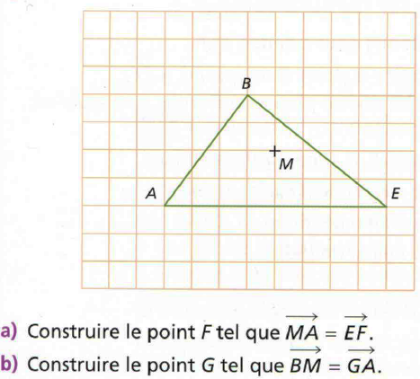
Exercice 3

Exercice 4
On considère les point A(2, -1), B(5, 1) et C(3, 5).
- Lire puis écrire les coordonnées du point D tel que ABCD soit un parallélogramme.
- Calculer les coordonnées du point D en utilisant celles de A, B et C.
1
1
8
7
6
5
4
3
2
2
3
4
5
-1
-3
-4
-2
-6
-5
-7
-2
-3
-4
-5
-6
-1
9
0
6
-8
-9
y
x

……………………………………………………………………………………………………………………………………………………………………………………………………..………
………………………………………………………………………………………………………………………………………………………………………………………………………………………………………………………………………………………………………………………………………………………………………………………………………………………………………………………………………………………………………………………………………………………………………………………………………………………………………………………………………………………………………………………………………………………………………………………………………………………………………………………………………………………………………………………………………………………………………………………………………………………………………………………………………………………………………………………………………………………………………………………………………………………………………………………………………………………………………………………………………………………………………………………………………………………………………………………………………………………………………………………………………………………………………………………………………………………………………………………………………………………………………………………………………………………………………………………………………………………………………………………………………………………………………………………………………………………………………………………………………………………………………………………………………………………………………………………………………………………………………………………………………………………………………………………………………………………………………………………………………………………………………………………………………………………………………………………………………………………………………………………………………………………………………………………………………………………………………………………………………………………………………………………………………………………………………………………………………………

Exercice 5
On considère les points A(-4, -3), B(2,-1) et C(1,2).
- Faire une figure.
- Calculer les longueurs AB, BC et AC.
- Montrer que le triangle ABC est rectangle.
1
1
8
7
6
5
4
3
2
2
3
4
5
-1
-3
-4
-2
-6
-5
-7
-2
-3
-4
-5
-6
-1
9
0
6
-8
-9
y
x

………………………………………………………………………………………………………………………………………………………………………………………………………………………………………………………………………………………………………………………………………………………………………………………………………………………………………………………………………………………………………………………………………………………………………………………………………………………………………………………………………………………………………………………………………………………………………………………………………………………………………………………………………………………………………………………………………………………………………………………………………………………………………………………………………………………………………………………………………………………………………………………………………………………………………………………………………………………………………………………………………………………………………………………………………………………………………………………………………………………………………………………………………………………………………………………………………………………………………………………………………………………………………………………………………………………………………………………………………………………………………………………………………………………………………………………………………………………………………………………………………………………………………………………………………………………………………………………………………………………………
………………………………………………………………………………………………………………………………………………………………………………………………………………
………………………………………………………………………………………………………………………………………………………………………………………………………………
………………………………………………………………………………………………………………………………………………………………………………………………………………

